

**Project Report On**

**SHAA Dry Fruits**

**Table Of Contents**

1. **Acknowledgments**
2. **Information About Developers**
3. **Introduction About Project**
4. **Analysis**
5. **Screen Shots**
6. **Final Statement**

**Acknowledgments**

The combine Study on this project is an honor for our group members.

We were eager to make such a dynamic and interesting project, which may provide us with a huge amount of practical knowledge and will help us use our skills efficiently.

Our heartiest appreciation and gratitude towards our teachers, whose help, dedication and encouragement has helped our team members to successfully, achieve our goals.

We are grateful to Aptech for providing us necessary facilities and the support which we needed and also for providing us the opportunity to practically implement what we have learned, which will help, help us in future.

**Information About Developers**

|  |  |
| --- | --- |
| Student1500441 | Hammad Khokhar |
| Student1500338 | Asma Noor |
| Student1500360 | Areesha Usman |
| Student1512003 | Suman Nawaz |

**Introduction About Project**

Dry fruits, often heralded as nature's treasures, are the dehydrated forms of fruits, packed with concentrated nutrients, flavors, and health benefits. Through a meticulous process of dehydration.

This project seamlessly combines HTML, CSS, JavaScript, and Bootstrap to create an immersive and user-friendly website that caters to both aesthetic appeal and functionality.

By leveraging modern web technologies, the website provides a visually stunning experience while ensuring seamless navigation and easy access to information.

Whether it's exploring the extensive product catalog, requesting a quote, or contacting the company, Beyond their delicious taste, dry fruits boast a wealth of health benefits. They are a concentrated source of essential vitamins, minerals, fiber, and antioxidants, which support overall well-being.

**Analysis**

**Purpose**  
  
Dry fruits, also known as dried fruits or nuts, serve multiple purposes and offer various benefits:

* ****Nutritional Value****: Dry fruits are concentrated sources of essential nutrients such as vitamins, minerals, and dietary fiber. They provide a convenient and nutrient-dense snack option.
* ****Health Benefits****: Many dry fruits are rich in antioxidants, healthy fats, and other bioactive compounds that contribute to overall health and well-being. Consuming dry fruits regularly may help reduce the risk of chronic diseases such as heart disease, diabetes, and certain types of cancer.
* ****Weight Management:**** Despite being calorie-dense, dry fruits can be beneficial for weight management when consumed in moderation. They provide a feeling of satiety due to their fiber and protein content, which may help curb hunger and prevent overeating.
* ****Energy Boost****: Dry fruits are a natural source of energy due to their carbohydrate content, making them an excellent choice for replenishing energy levels during physical activity or as a quick pick-me-up during the day.

Overall, the purpose of dry fruits extends from their nutritional value to their convenience and versatility, making them a valuable addition to a healthy diet.

**Working**

Working in a dry fruit company offers a dynamic and rewarding experience across various departments. From production and procurement to sales and marketing, employees play vital roles in ensuring the quality, promotion, and distribution of dried fruits and nuts. Whether managing supply chains, developing innovative products, or providing excellent customer service, individuals in this industry contribute to delivering nutritious and delicious options to consumers worldwide.

Users can browse through the website's product catalog and discover a wide range of dry fruits. They can view product details, such as descriptions, prices, dimensions, and images, to gain a better understanding of the available options.

A website dedicated to dry fruits typically provides comprehensive information about various types of dried fruits, including their nutritional value, health benefits, culinary uses, and purchasing options.

**Home page**

This is the home page of website

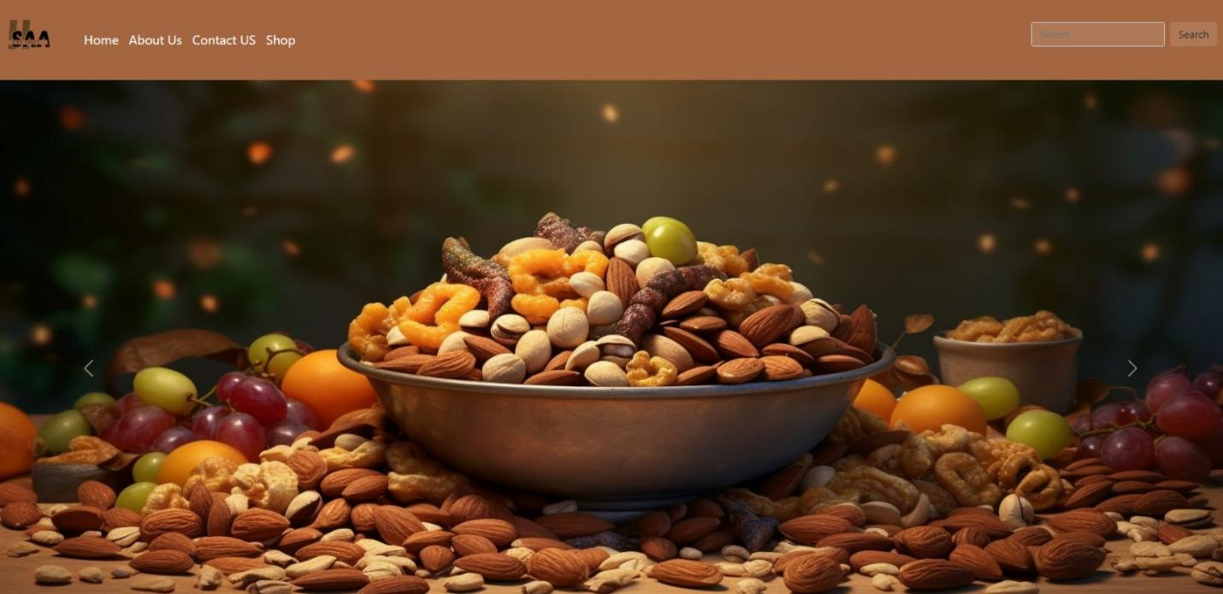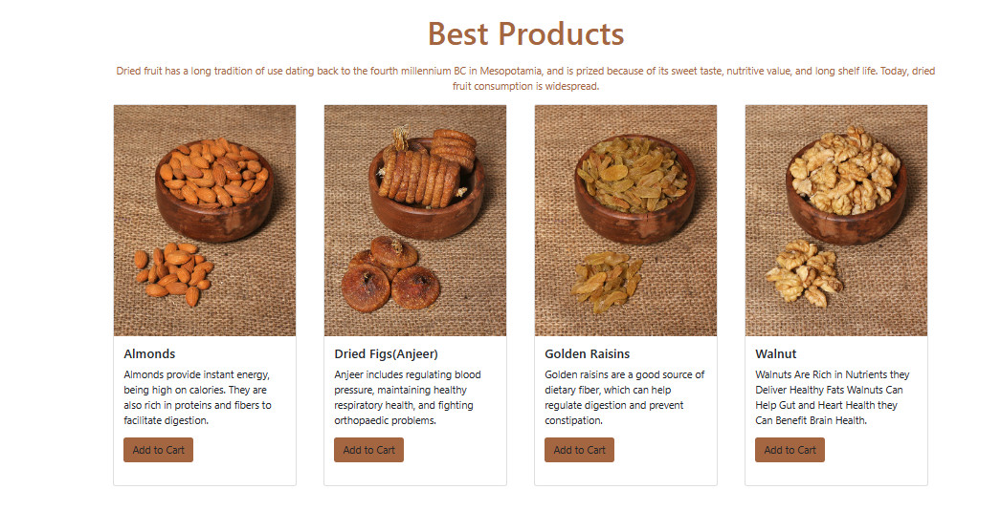

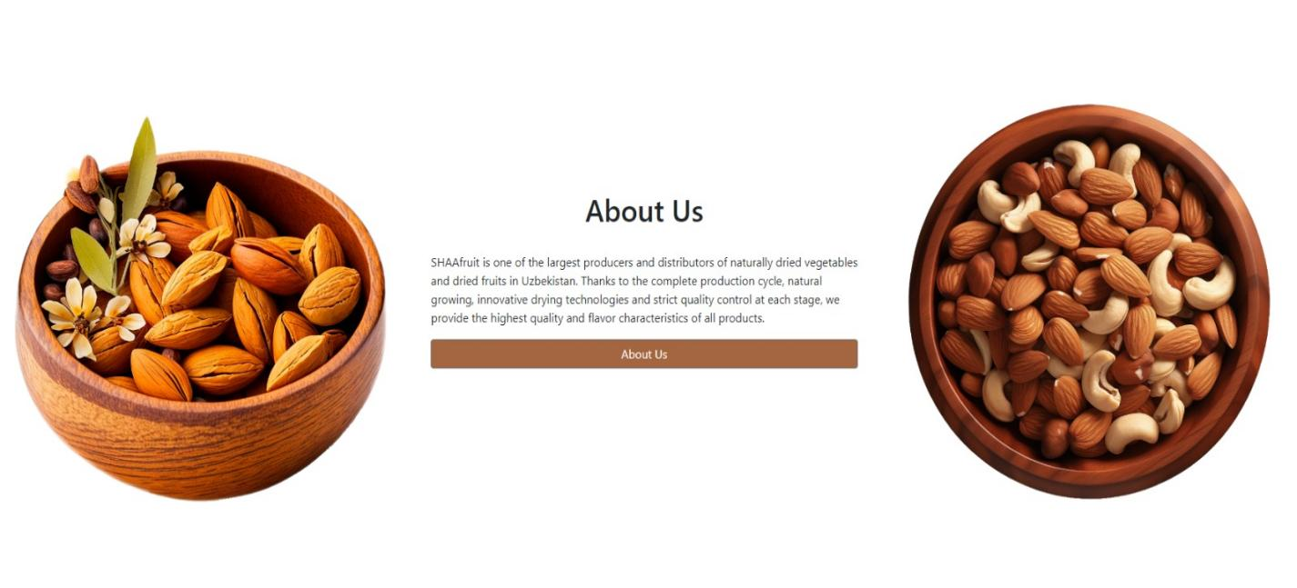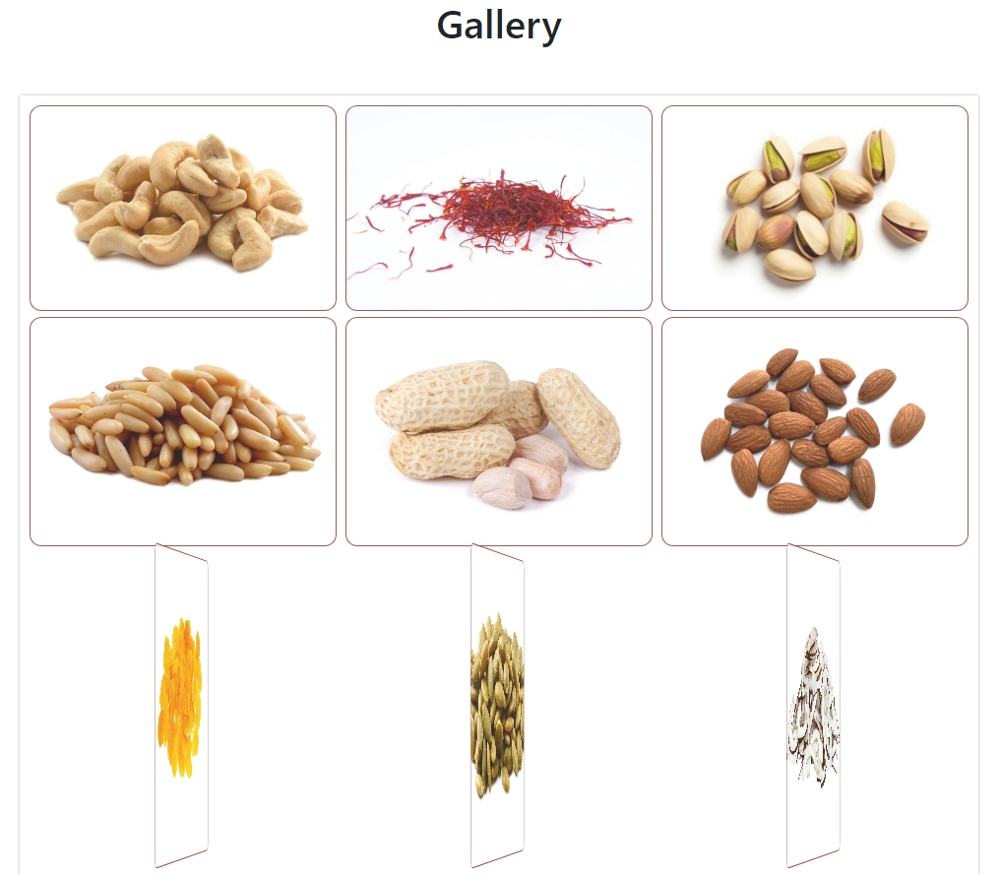



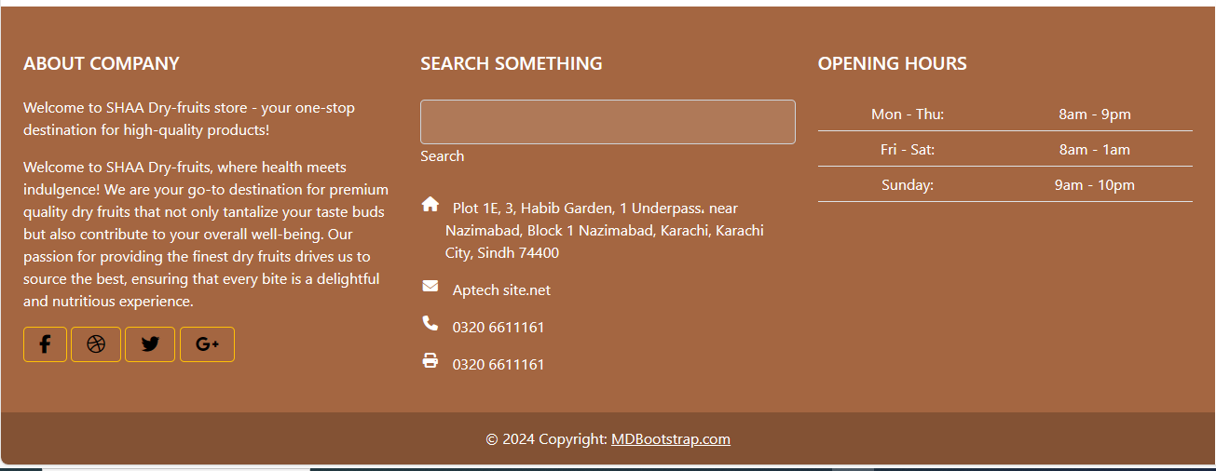

**Shop page**

From this page customer can shop and explore Dry Fruits.

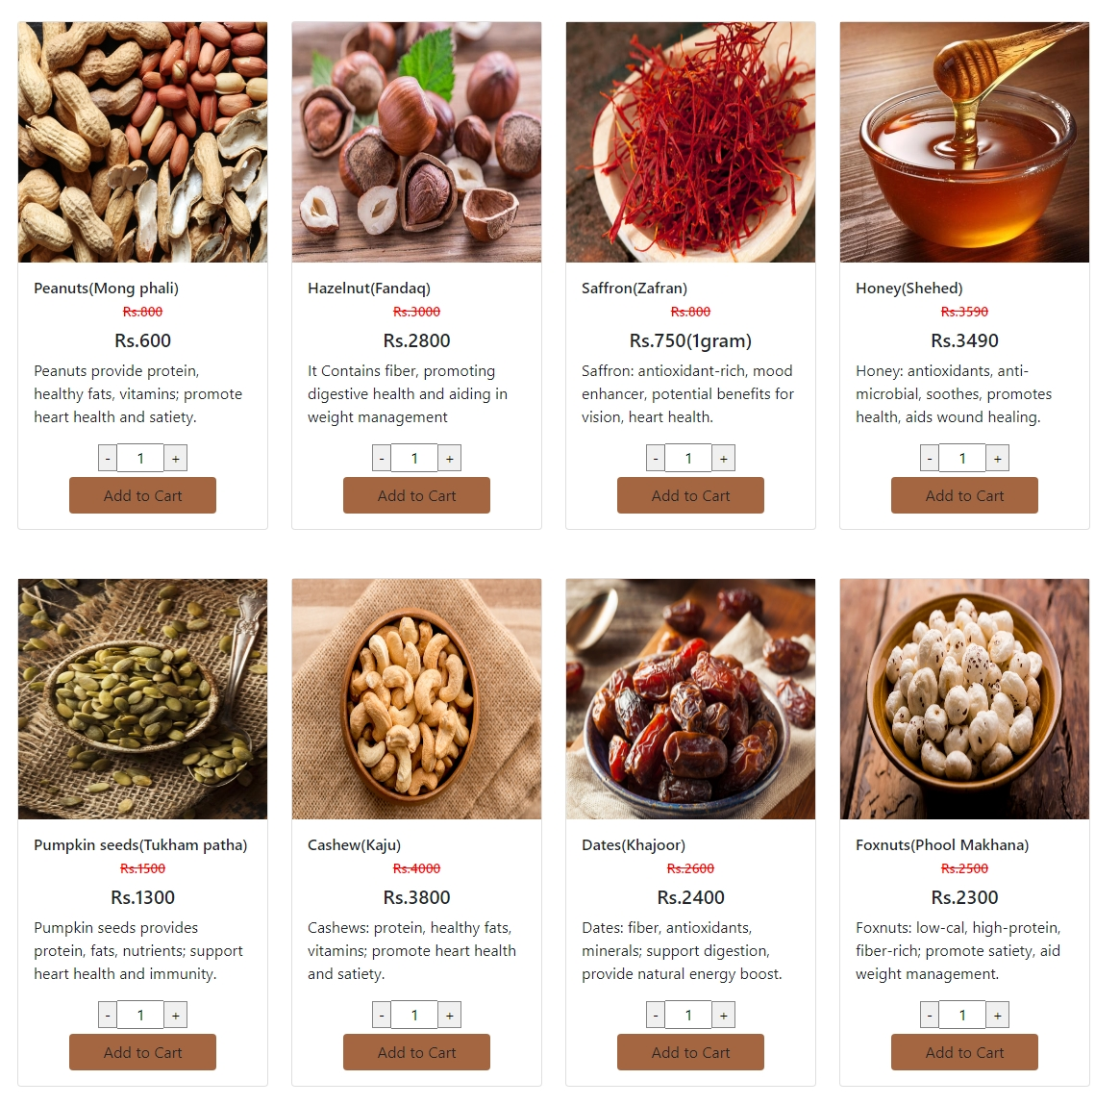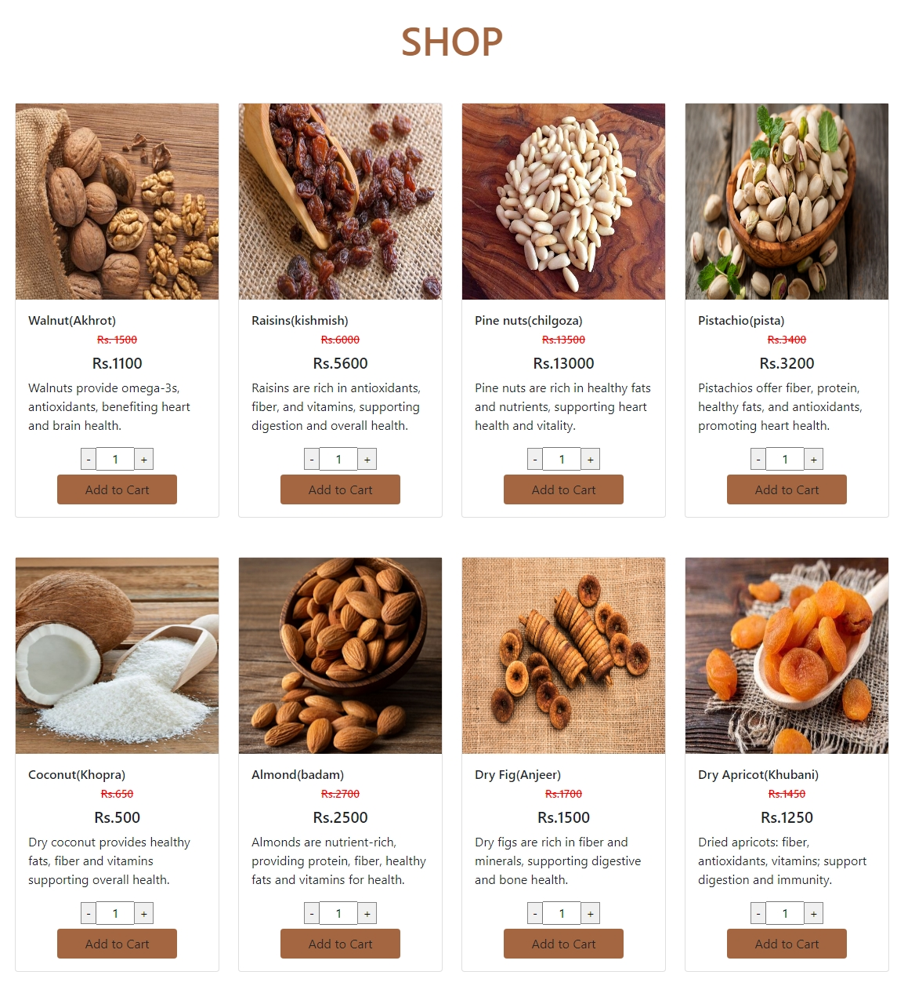

**Contact us page**

Customers can contact us through this page

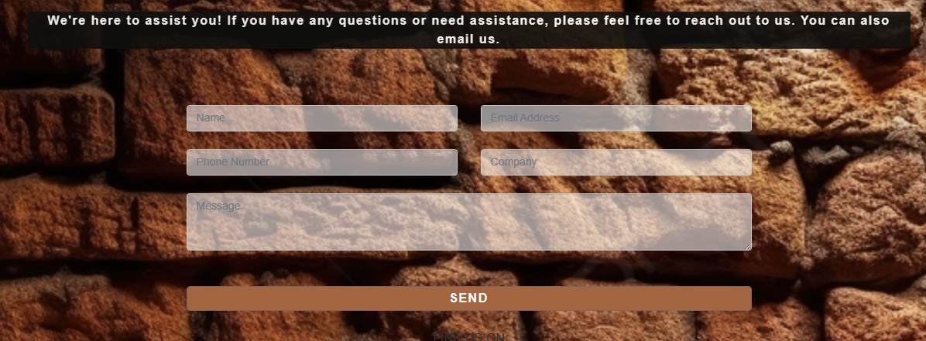

**Map**

Through this map customers can visit our store

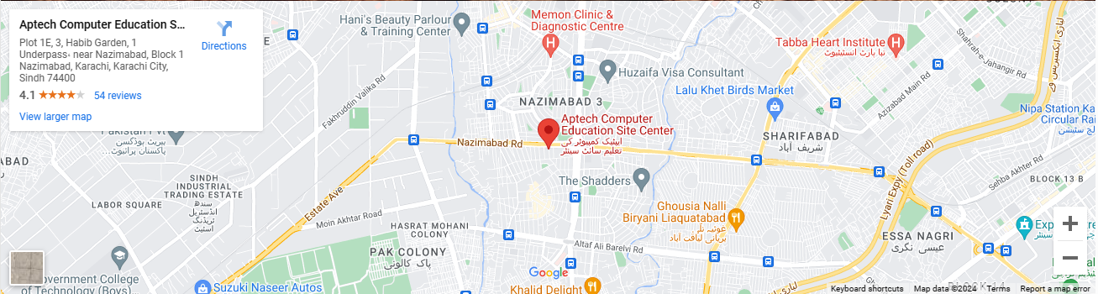

**About us page**

From this page customer can get details about us.

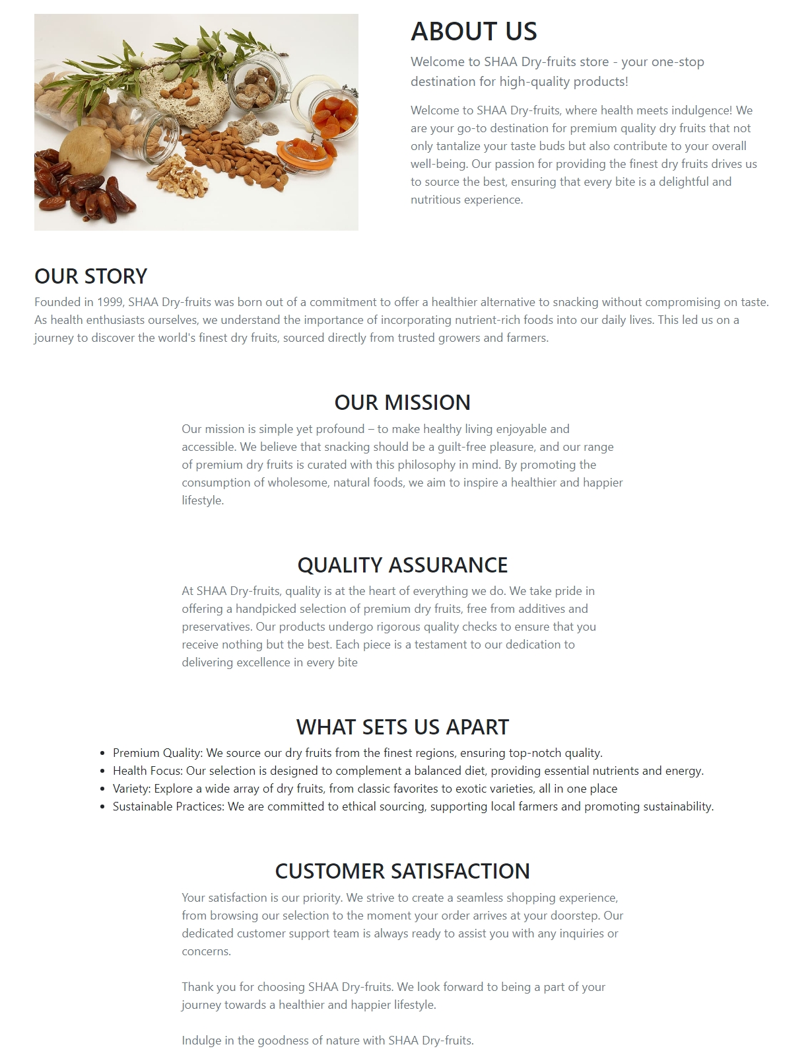

**Ramadan Offer**

From this page customer can buy gift box for their loved ones



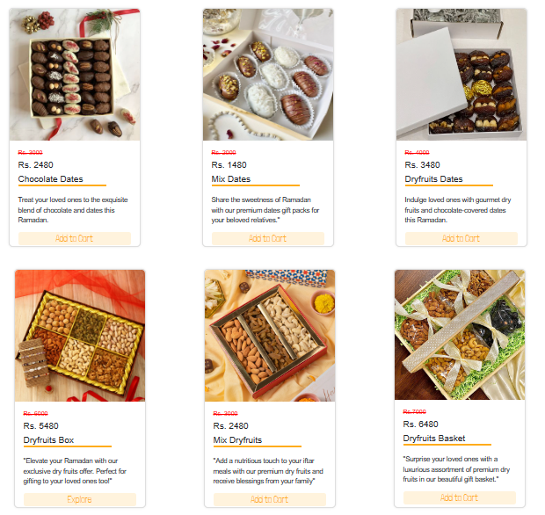

**Final Statement**

This E Project was created with Firm Determination. We students did lot of hard work to complete this project on time.

We did our best to made this project perfect, work full, help full, easy to use and Qualified as much as possible.

We Kept the future technologies and usage in our mind while making this project.

We hope That APTECH will like our project and will appreciate our hard work and Firm Determination.

THANK YOU!

**Documentation Created By**

**Areesha Usman.**